OUTPUT RESULTS FOR Question 6,7,8.i.e findMedian, closestNumbers and dayOfProgrammer

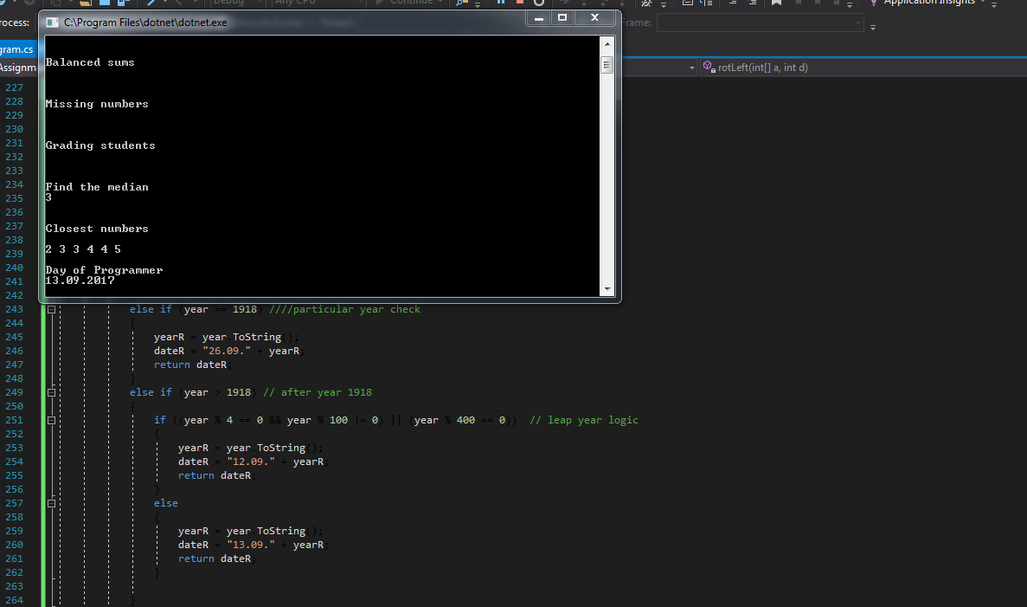

OUTPUT FOR :Left rotation, maximum toys

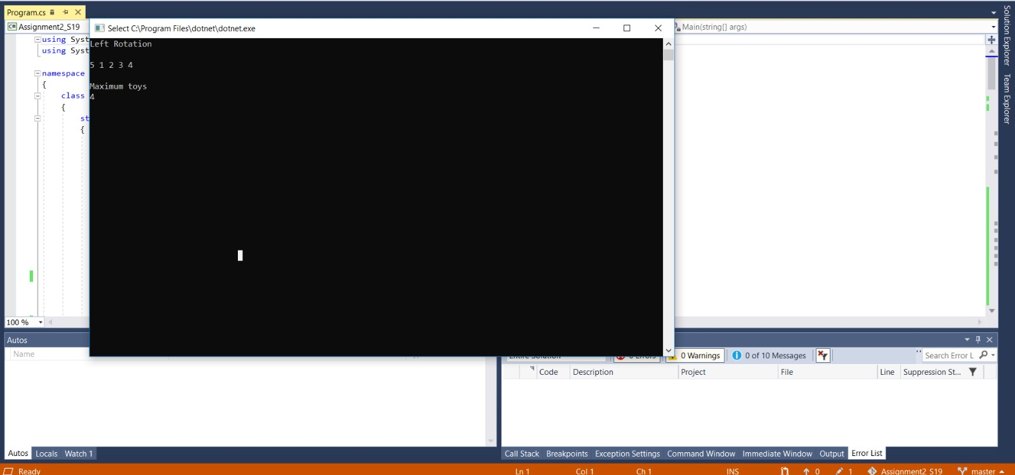

OUTPUT FOR: Balanced sums, missing numbers, grading students

